# Exercises: MySQL Introduction

This document defines the **exercise assignments** for the ["PHP Fundamentals @ Software University.](https://softuni.bg/courses/php-basics/)

## Start MySQL

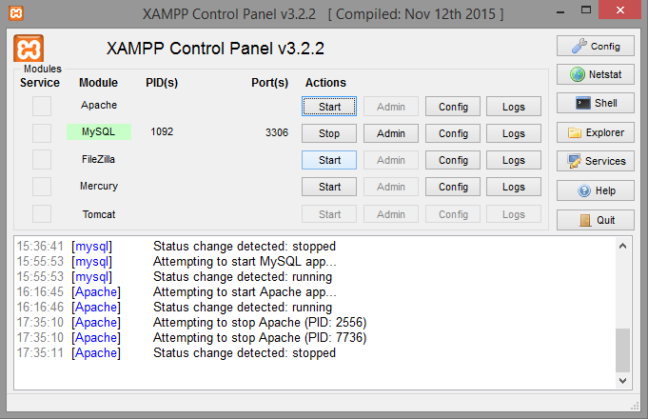

## Download and Install HeidiSQL

Go to the HeidiSQL web site and **download HeidiSQL** <http://www.heidisql.com/download.php>. Then **install** it.

## Create New Database

* Connect to MySQL Server with user **root** and the password you set up earlier.

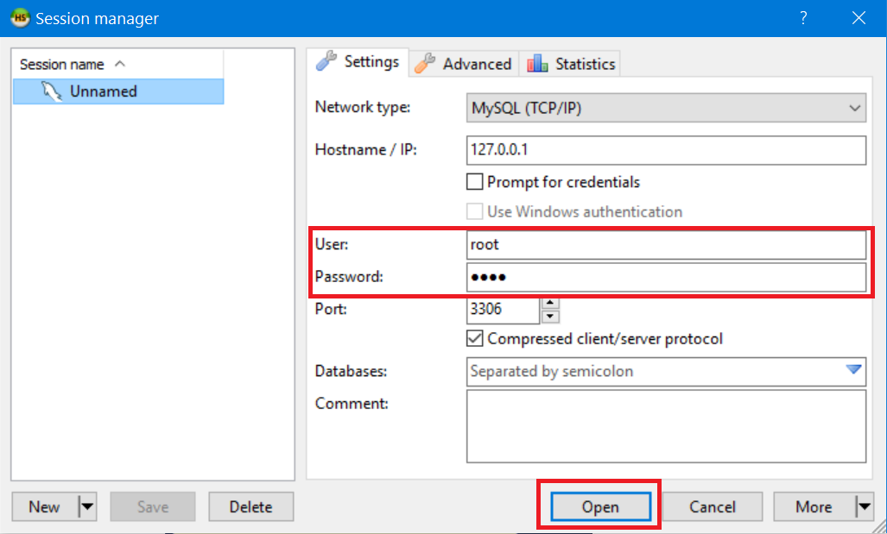

* Create new database

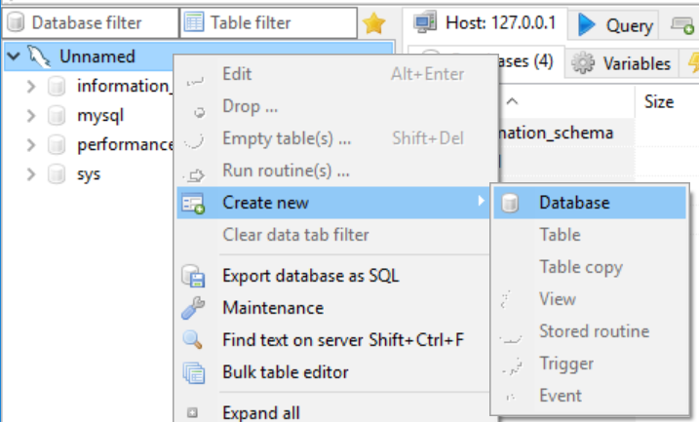

* Type the name of the database and click OK. This will create your database.

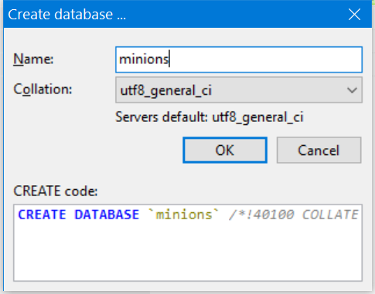

## Create Table

* Create **table** **Minions**

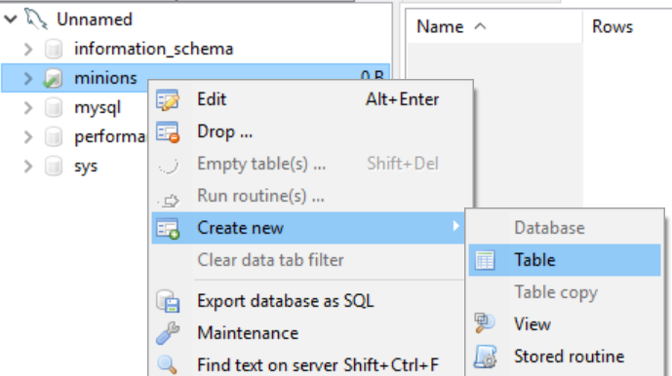

* Create columns **id, name, age**. Id and name are **required**; Age should **allow null values**.

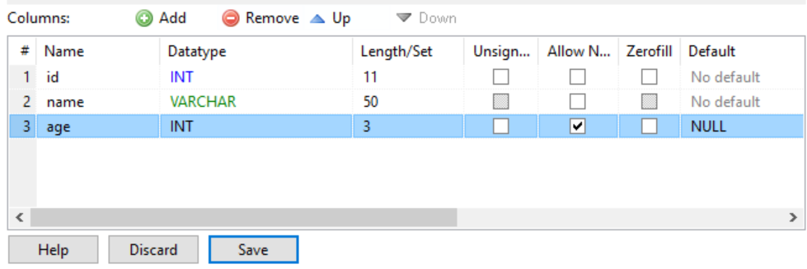

* Set the **id** as **primary key**.

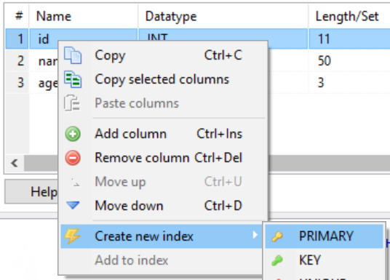

## Insert Data in the Table

Insert data in the table as its show on the picture

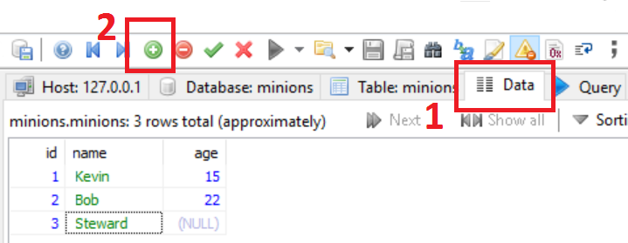

## Select Data from Table

* Select **all columns** from the Minions table.

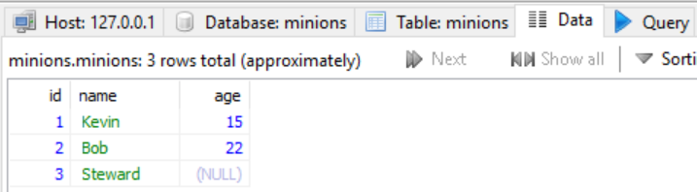

* Open Query tab, then write the SQL.
  + * Select **only names** from Minions table.
  + ** **Order** them **ascending by name**

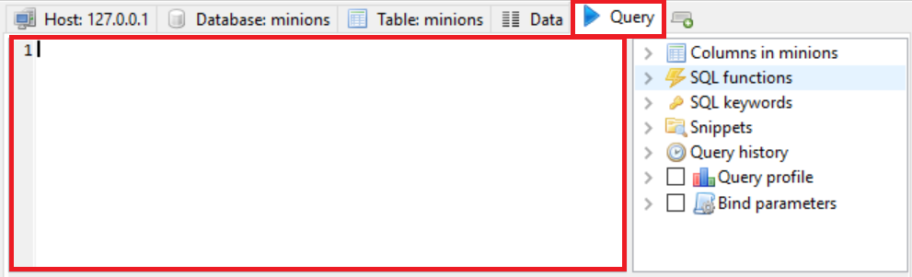

## Update One Record

Change **Stuart’s age** from **NULL** to **10**

## *Update All Records

Change all of the Minions age to be + 1 years.

## Delete Record

Open Data tab for the table, **right click** on the row where **Bob** is situated and delete it.

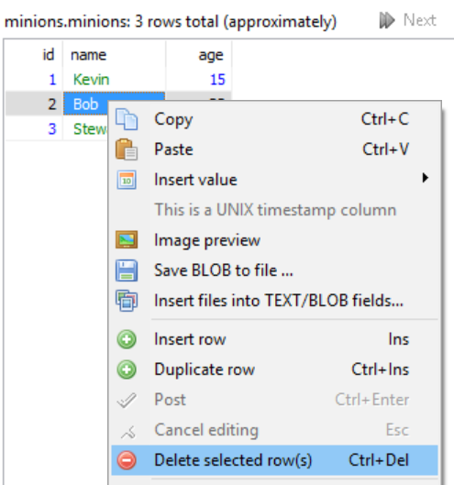

## Create New Table

Create new table **towns**. Every town has **id (int)** and **name (text)**. Make the **id** column **primary key**.

## **Connect Tables

Now let’s make a connection (or relationship) between our two tables. First we need modify our minions table. Add column **town_id** in it **(IMPORTANT: The type of the column must be the same as the type of the column id of the towns table)**.

### Hint

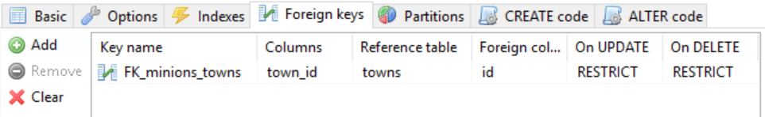

## Create New Database

Now on your own create a new database **school**. Add a few tables to the database: **students (id, name, age, phone_number)**, **classes (id, name, max_students), teachers(id, name, class)**. Add columns for the tables. Populate the tables with random content. Then delete and make changes in some records.

## *Generate SQL Script

Generate SQL script from the **school** database. View the script file and try to understand different commands. Execute the script.